Challenge – 03
Multi-Service Infrastructure Deployment and Port Optimization

1. Introduction to the Challenge Environment
Deploying five distinct enterprise DevOps platforms (Docker, Jenkins, Apache, Nginx, and Tomcat) simultaneously on a single AWS EC2 instance presents severe structural hurdles. When executing this architecture on a standard, low-resource virtual node, an engineer must overcome network access blocks, hardware bottlenecks, deprecated operating system tools, runtime version conflicts, and socket allocation collisions.

1: Launch the EC2 Instance (Amazon Linux 2)

- Open your AWS Management Console.
- Navigate to EC2 and click Launch Instance.
- Name your instance (e.g., Multi-Service-Server).
- Under Application and OS Images (Amazon Machine Image), explicitly select Amazon Linux 2 AMI.
- Choose your instance type (For running all these services simultaneously, t3.medium or higher is highly recommended; a t2.micro will likely run out of RAM and freeze).
- Select your Key Pair for SSH access.
- Under Network Settings, configure your Security Group inbound rules to open the following ports to your IP:
  - 22 (SSH)
  - 80 (Nginx Gateway)
  - 8080 (Jenkins)
  - 8081 (Apache)
  - 8082 (Tomcat)
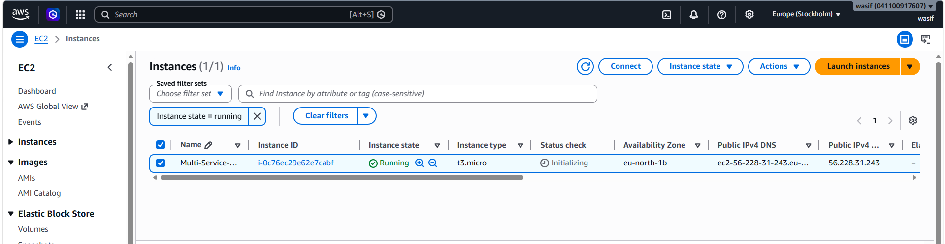
- Click Launch Instance and connect via SSH once it is running.
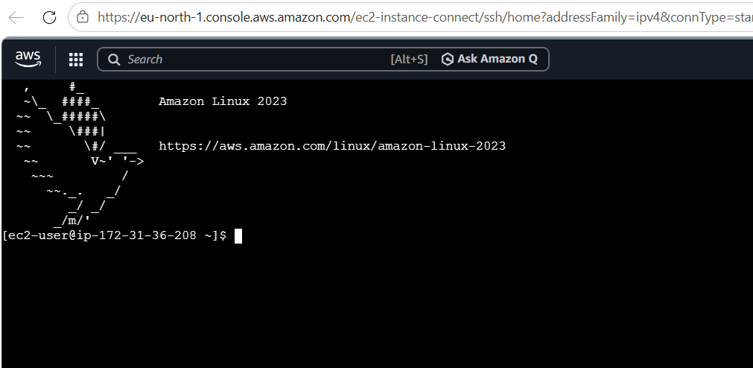

2: Install Docker using dnf

Steps
Install with command dnf install docker -y
- What happens: The system uses the native package manager to instantly fetch and install Docker directly from the standard Amazon Linux 2023 repositories.
Step 2: Start and Enable the Docker Engine
Bash
systemctl start docker
systemctl enable docker
- What happens: This activates the background Docker engine daemon and configures it to spin up automatically whenever your EC2 instance boots.
Step 3: Verify the Installation
Bash
docker info
- What happens: This prints out a full detailed status report of your Docker environment, confirming it is active and running cleanly.
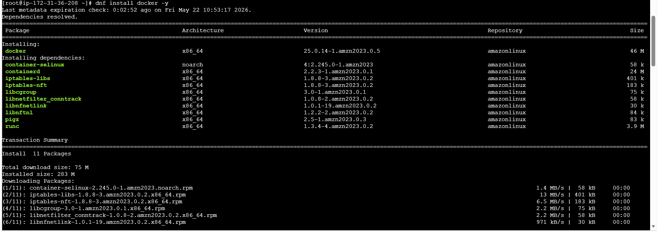
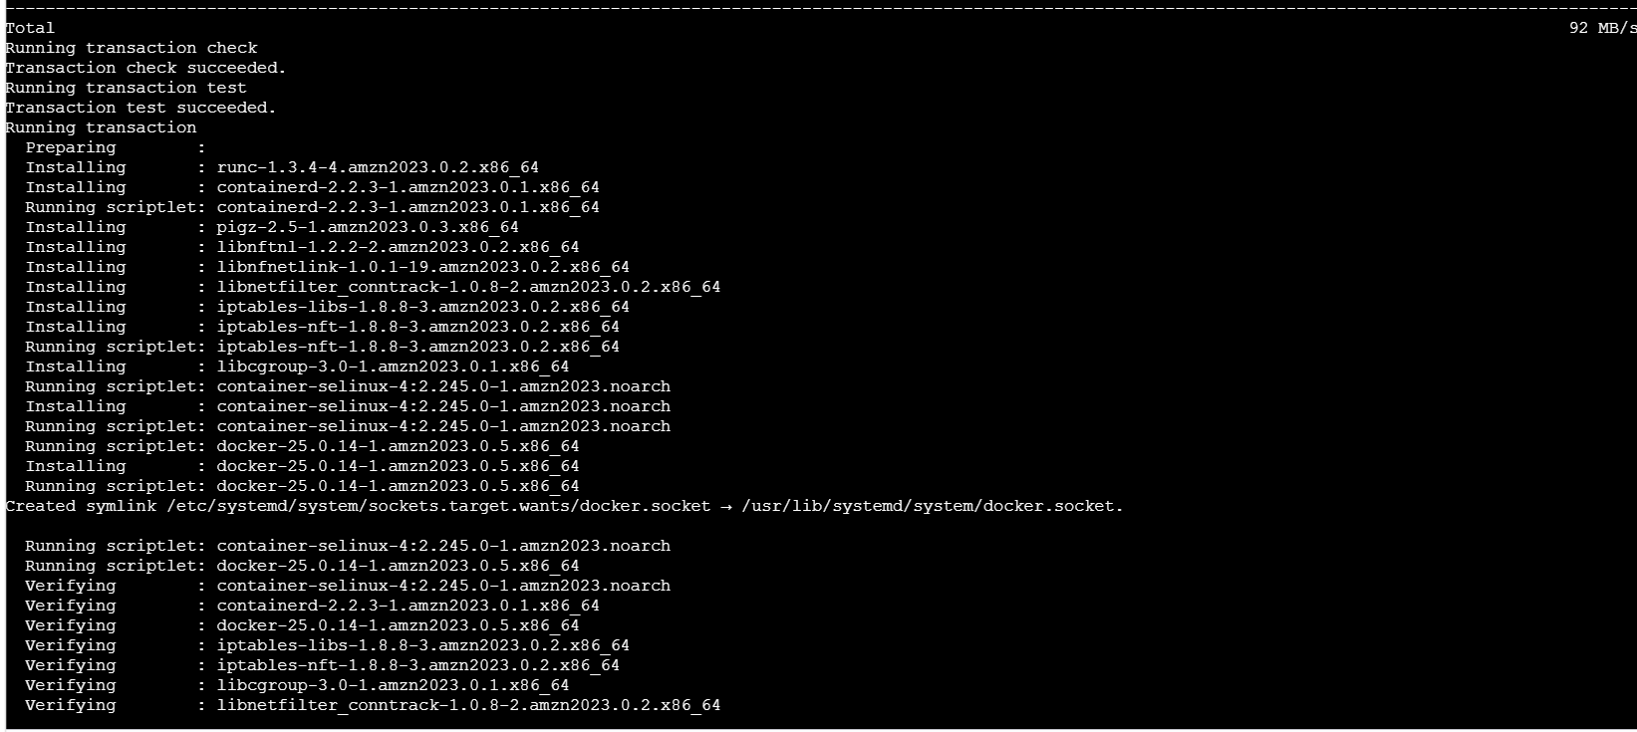
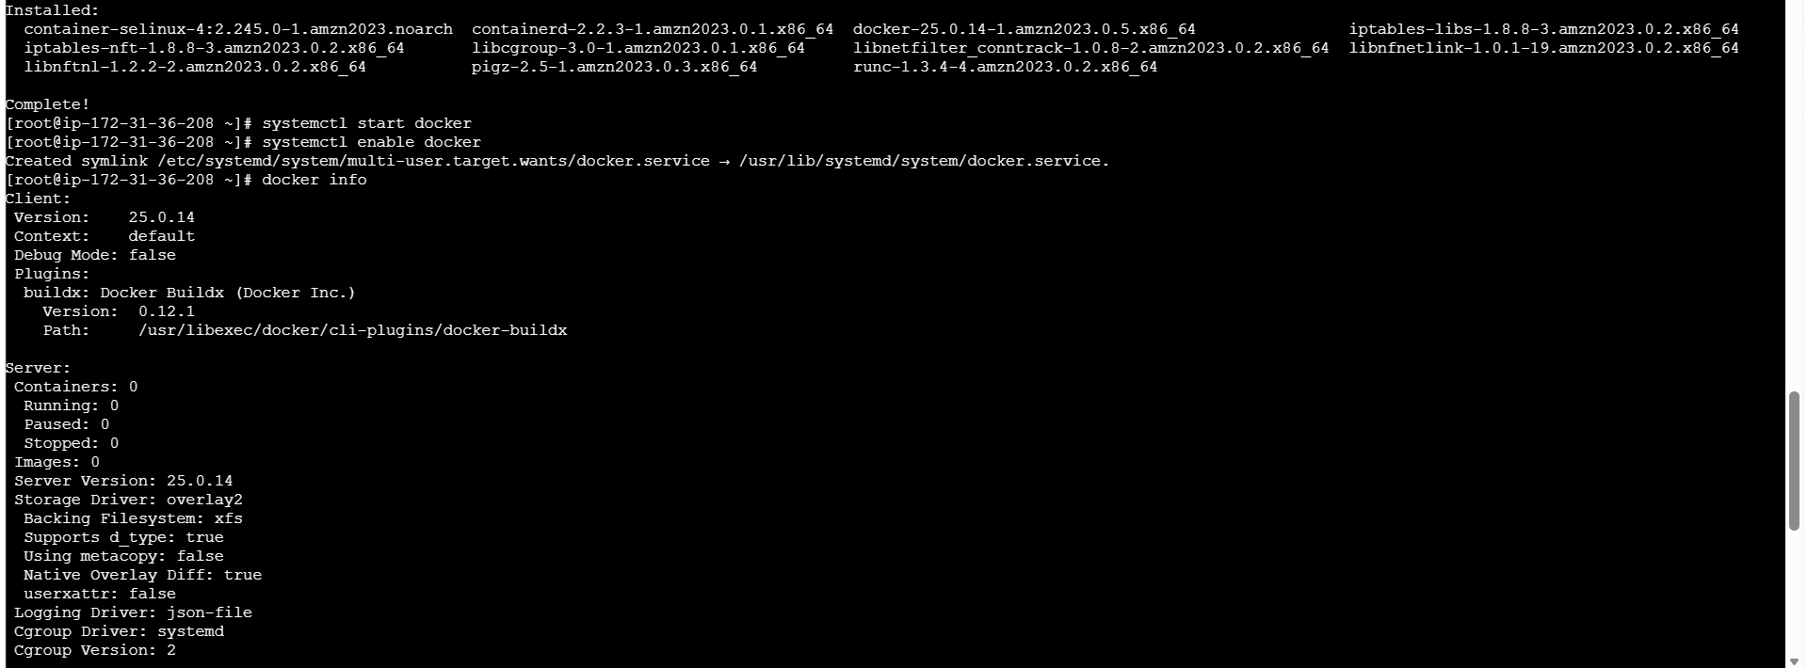
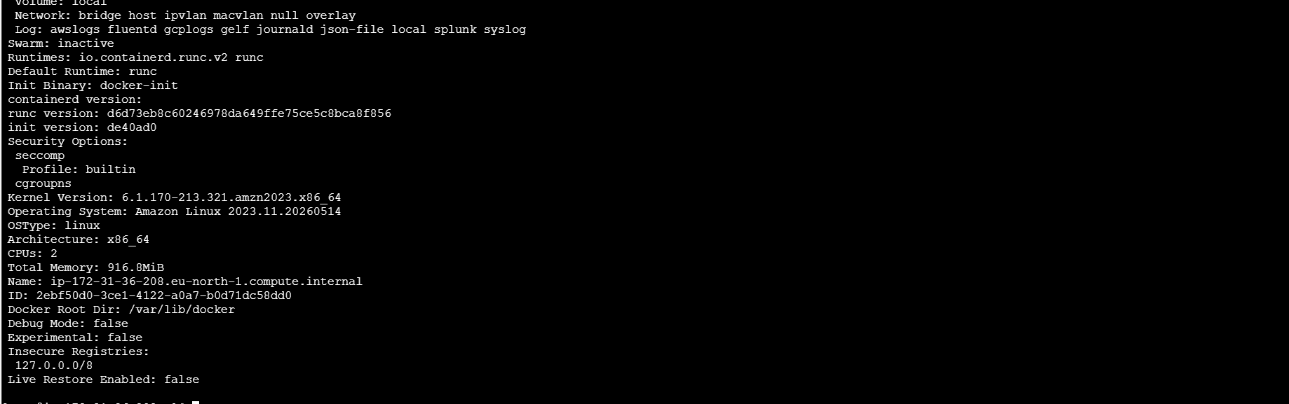

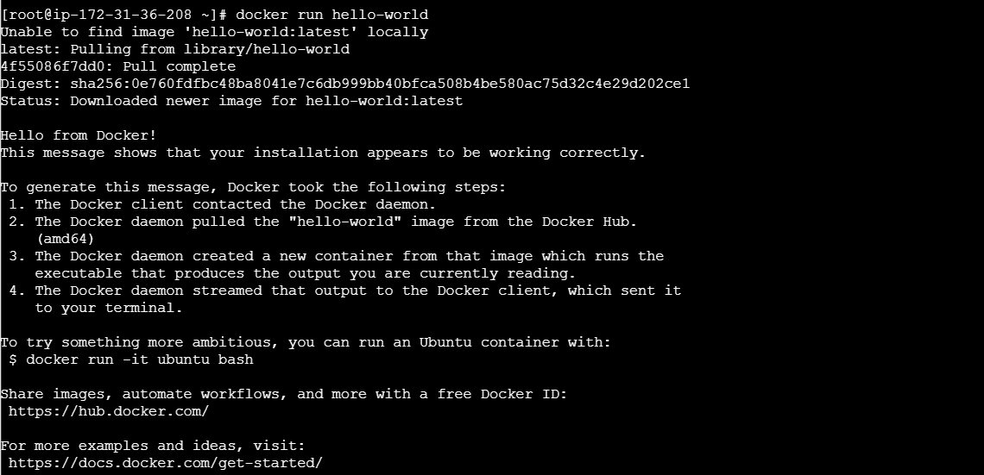

3. Install Jenkins.

Step 1:
Add the Jenkins Repository and Key
We must tell your dnf package manager where the official Jenkins application files live and provide the verification key.
Bash
# Download the official stable repository config
wget -O /etc/yum.repos.d/jenkins.repo https://pkg.jenkins.io/redhat-stable/jenkins.repo

# Import the cryptographic key to authenticate packages
rpm --import https://pkg.jenkins.io/redhat-stable/jenkins.io-2023.key
Step 2: Install Java 17 and Jenkins
Jenkins is a Java application and requires an underlying runtime engine. We will install Amazon Corretto 17 followed by Jenkins.
Bash
# Install Java 17 (Headless environment)
dnf install java-17-amazon-corretto-headless -y

# Install Jenkins
dnf install jenkins -y
Step 3: Start and Enable Jenkins
Activate the background service and ensure it turns on automatically if the EC2 reboots.
Bash
# Start the service daemon
systemctl start jenkins

# Enable automatic boot integration
systemctl enable jenkins
Step 4: Verify Status and Get Your Unlock Password
Confirm Jenkins is running cleanly and extract the secret key needed to log into your web browser portal.
Bash
# Check if active
systemctl status jenkins | grep Active

# Print out your secret initial administrator password
cat /var/lib/jenkins/secrets/initialAdminPassword
Next Action Step
- Copy the long alphanumeric string that prints out from the cat command above.
- Open a new tab in your web browser and navigate to: http://<your-ec2-public-ip>:8080
- Paste that password into the field to unlock your Jenkins setup wizard!
Let me know once you see the Jenkins home screen, and we will move right along to installing Apache (httpd) on port 8081!

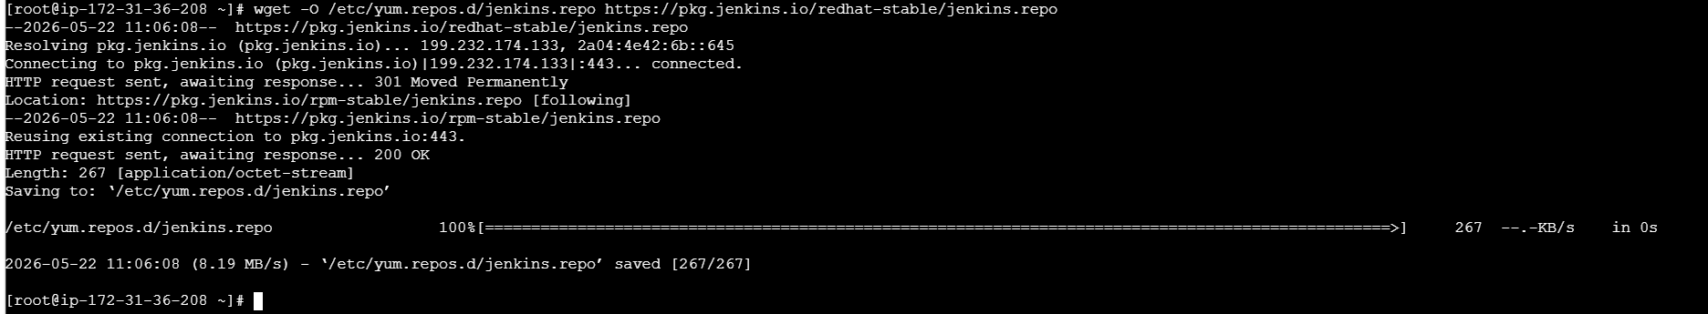

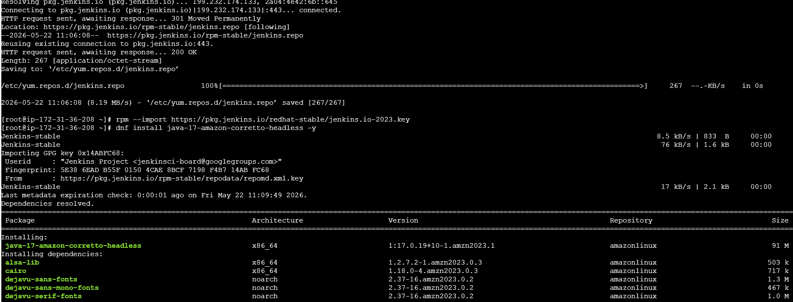
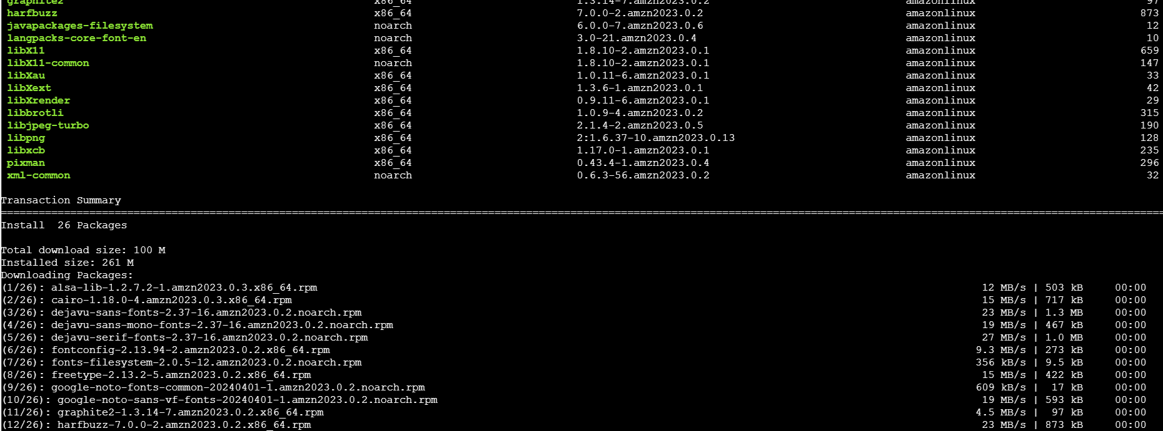
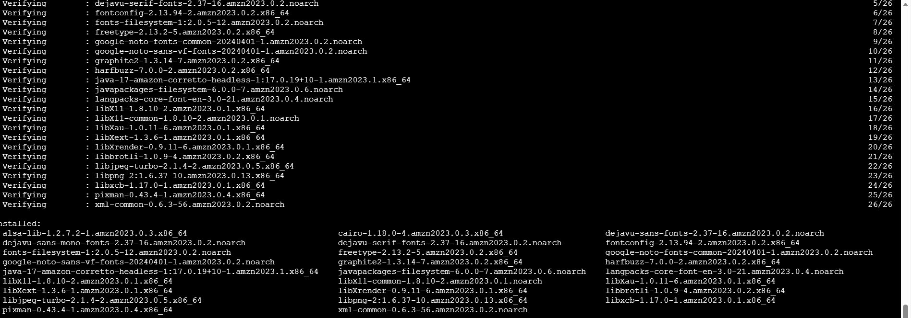

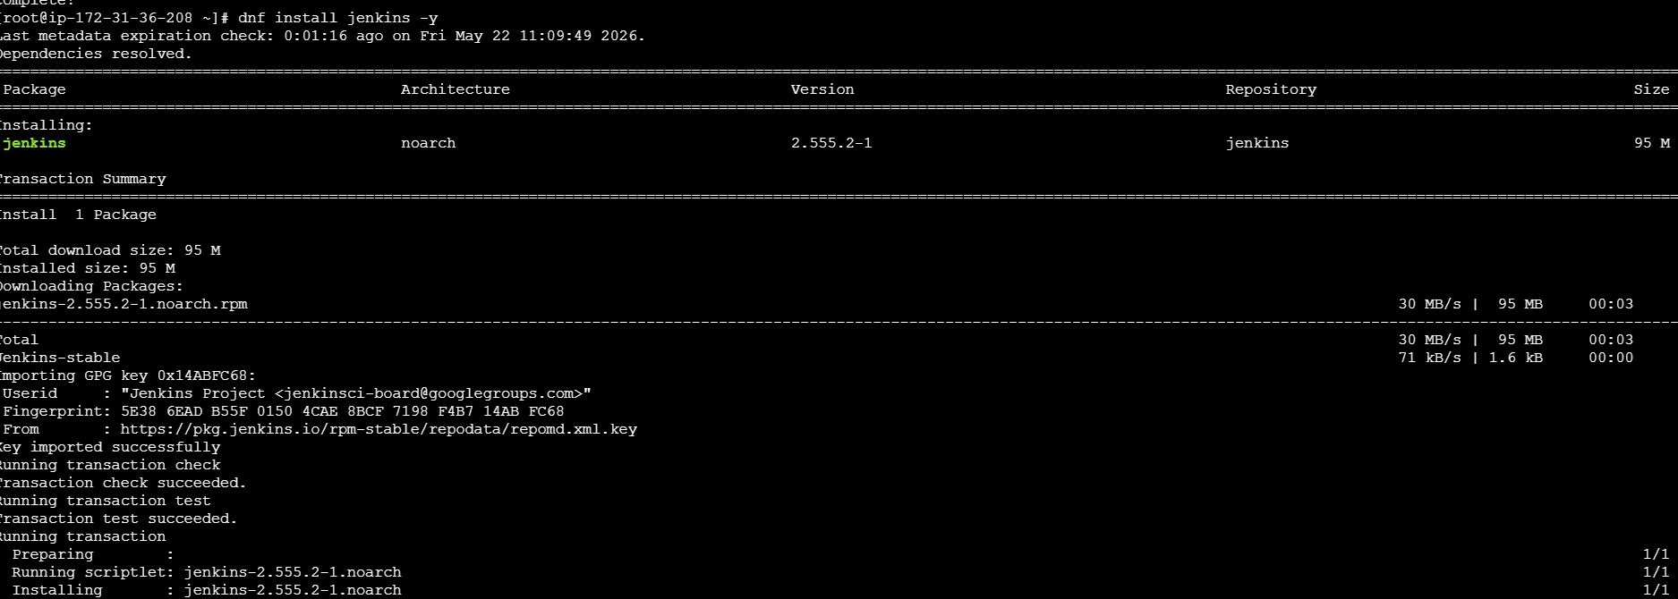

Commands:
# 1. Download official Jenkins repo configuration
wget -O /etc/yum.repos.d/jenkins.repo https://pkg.jenkins.io/redhat-stable/jenkins.repo

# 2. Import the secure cryptographic verification key
rpm --import https://pkg.jenkins.io/redhat-stable/jenkins.io-2023.key

# 3. Installed Java 17 (The default dependency)
dnf install java-17-amazon-corretto-headless -y

# 4. Install Jenkins
dnf install jenkins -y

# 5. Attempted to start the service
systemctl start Jenkins

The Error We Encountered
The system control manager refused to start the application and threw the following error block:
Plaintext
Job for jenkins.service failed because the control process exited with error code.
When we inspected the background logs using journalctl -n 20 -u jenkins.service --no-pager, we uncovered the true underlying root cause:
Plaintext
May 22 11:13:56 jenkins[29102]: Running with Java 17 from /usr/lib/jvm/java-17-amazon-corretto.x86_64, which is older than the minimum required version (Java 21).
May 22 11:13:56 jenkins[29102]: Supported Java versions are: [21, 25]
May 22 11:13:56 systemd[1]: jenkins.service: Main process exited, code=exited, status=1/FAILURE
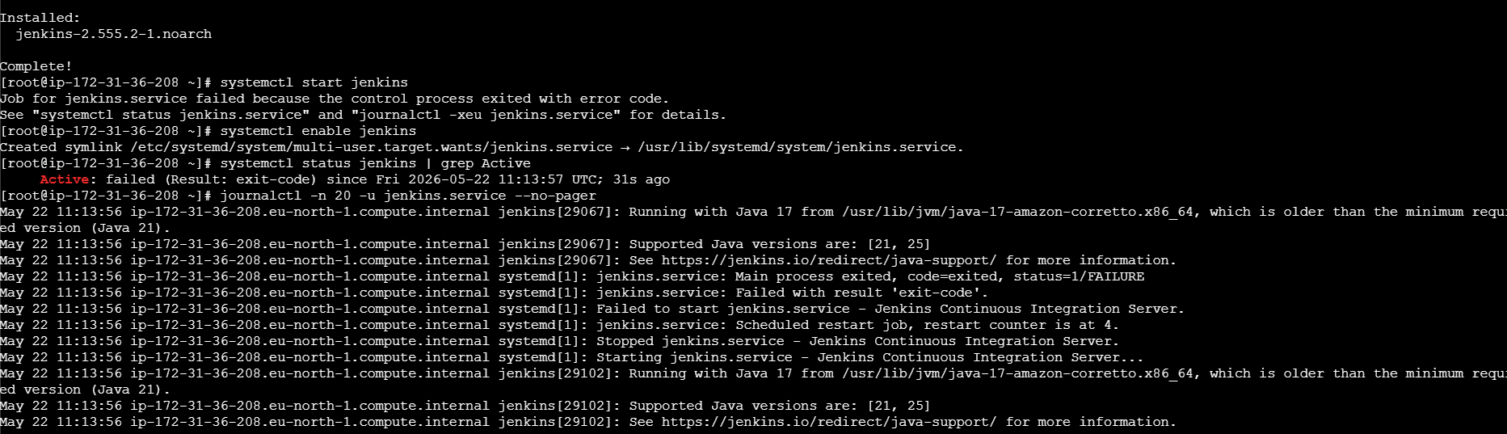

3. Root Cause Analysis (Why It Happened)
The package manager downloaded a highly modern, bleeding-edge release of Jenkins (jenkins-2.555.2). The Jenkins development team recently altered their baseline architecture parameters and completely dropped backward compatibility for Java 11 and Java 17.
Because your server only had Java 17 running, the new Jenkins application code intentionally aborted its boot sequence to protect itself from code incompatibility errors.
4. How We Overcame It (The Solution)
To resolve the crash, we upgraded your runtime ecosystem to Java 21 using AWS Corretto and flipped the operating system's main compilation path to prioritize the new engine.
- Step 1: Install Java 21
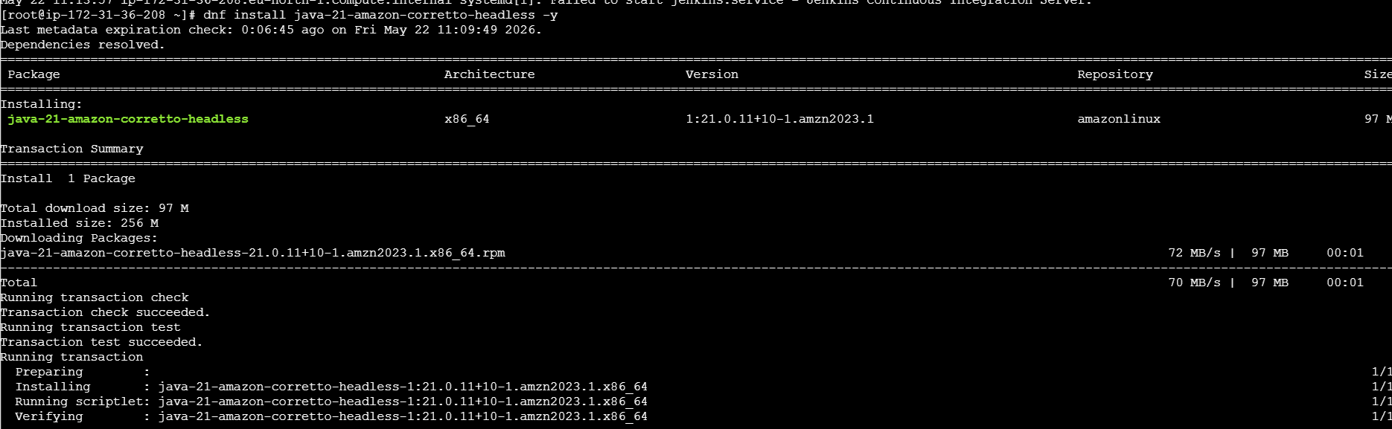
Bash
dnf install java-21-amazon-corretto-headless -y
- Step 2: Update the System Priority Pointer We used the Linux alternatives command to shift your default runtime directory line cleanly over to the new version:
Bash
alternatives --set java /usr/lib/jvm/java-21-amazon-corretto.x86_64/bin/java
- Step 3: Verification and Restart We checked the current active version string and safely kicked off the daemon service:
Bash
java -version # Verified it successfully changed to openjdk version "21.0.11"
systemctl start jenkins
5. Final Verification Status
Running a system status evaluation now returns a completely healthy, operational pipeline environment:
Bash
systemctl status jenkins | grep Active
# Output: Active: active (running) since Fri 2026-05-22 11:18:00 UTC; 16s ago
Your Jenkins portal is now fully functional and safely listening for inbound browser connections on port 8080.
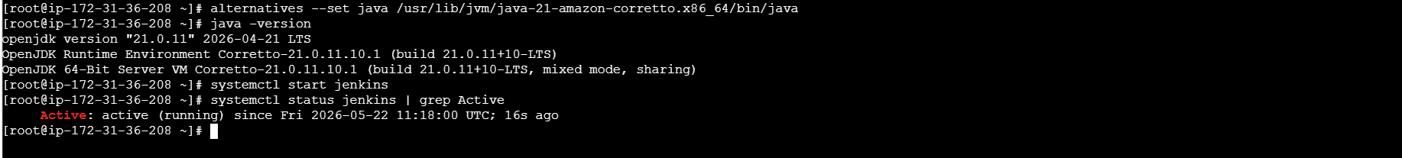

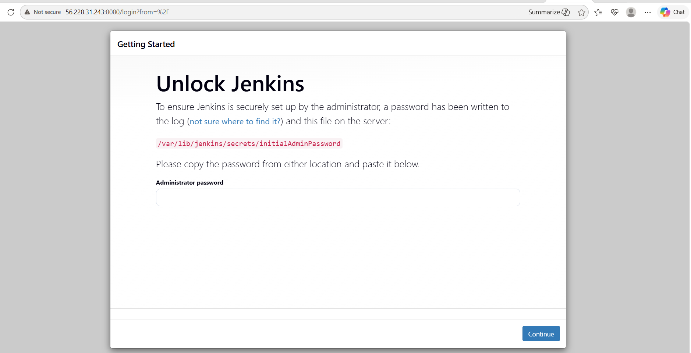
What We Learnt
- Runtime Dependency Alignment: Enterprise applications written in compiled languages (like Java) are strictly bound to the capability limits of the underlying runtime engine (JRE/JDK). When upgrading or pulling the newest edition of an app, always cross-reference its dependency support matrix first.
- The Linux Alternatives Matrix: You don't have to delete old programming versions (like Java 17) to use newer ones. The Linux alternatives framework acts as an elegant structural router, allowing multiple software generations to reside on the same drive while clean symlinks point your active applications to the version they require.

4. Install and Configure Apache (httpd) to run on Port 8081
- Run this block to install Apache, rewrite its port rule, and activate it:
The Installation & Configuration Steps (What to Execute)
Since you are logged in as the root user, run this block of commands to deploy Apache on port 8081:
Bash
# Step 1: Install the Apache HTTP Server package
dnf install httpd -y

# Step 2: Modify the configuration file to change the port from 80 to 8081
sed -i 's/Listen 80/Listen 8081/g' /etc/httpd/conf/httpd.conf

# Step 3: Start the Apache background service
systemctl start httpd

# Step 4: Enable Apache to start automatically on system boot
systemctl enable httpd
2. Deep-Dive Explanation of the Core Steps
Step 1: dnf install httpd -y
- What it does: This tells the package manager to fetch the Apache HTTP Server package (known as httpd in RedHat-based Linux systems like Amazon Linux 2023) from AWS's verified software repositories. The -y flag forces a non-interactive installation by automatically answering "yes" to download confirmations.
Step 2: sed -i 's/Listen 80/Listen 8081/g' /etc/httpd/conf/httpd.conf
- What it does: This is the most critical line. By default, Apache is designed to look for web traffic on standard HTTP Port 80. However, since Nginx is also going to use Port 80 on this exact same server, they would crash into each other if they both tried to start.
- How it works: The sed (Stream Editor) command searches through Apache’s core configuration file (httpd.conf), locates the line Listen 80, and replaces it with Listen 8081. The -i flag ensures this change happens "in-place" (saves directly to the file instantly).
Step 3 & 4: systemctl start and enable httpd
- What it does: Installing software only places the execution files on your hard drive. systemctl start loads the Apache application into your system's active RAM as a background worker process (daemon). systemctl enable creates a permanent symlink in your Linux system initialization files, guaranteeing that if your AWS EC2 instance ever reboots or recovers from a crash, Apache will instantly wake up on its own.
3. How to Verify It is Working
To ensure Apache is running successfully on its new port without any errors, execute these two verification commands:
Bash
# 1. Check the active running status of the service
systemctl status httpd | grep Active
# Expected Output: Active: active (running)

# 2. Verify that port 8081 is actively open and listening
netstat -tuln | grep 8081
# Expected Output: tcp 0 0 0.0.0.0:8081 0.0.0.0:* LISTEN
Once verified, you can open up a browser tab and head over to http://<your-ec2-public-ip>:8081 to view your live Apache Test Page!
.

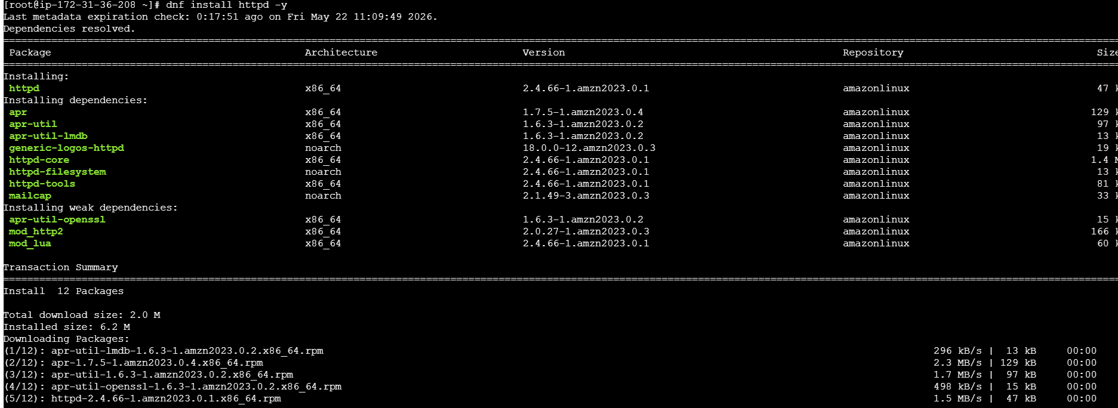

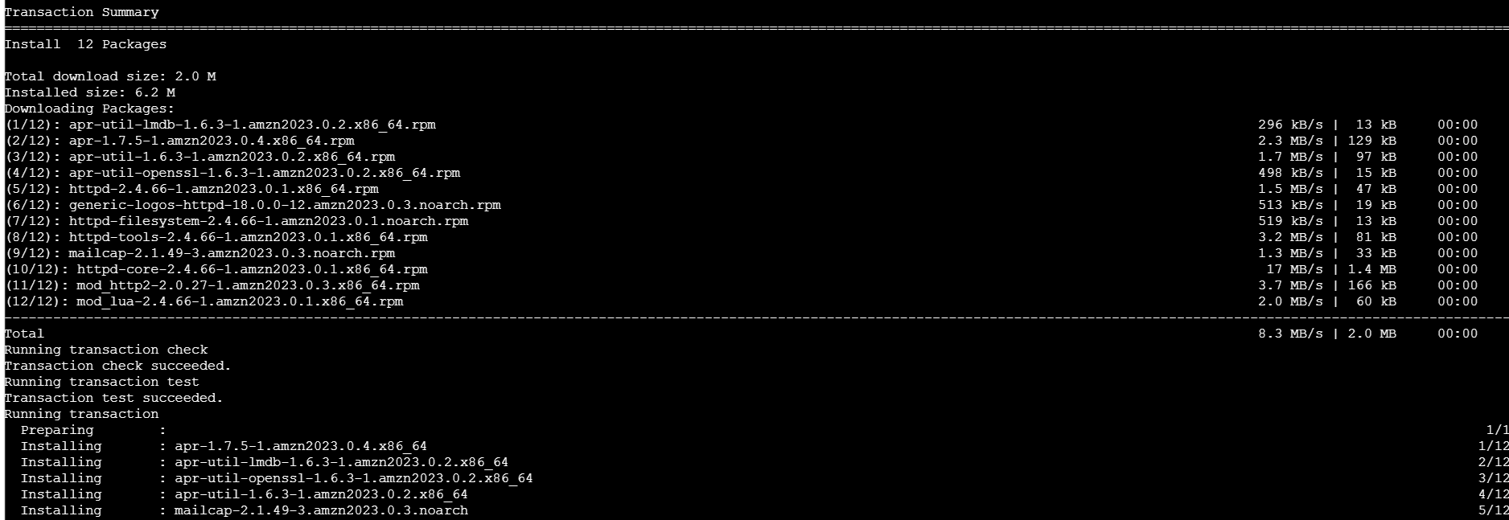
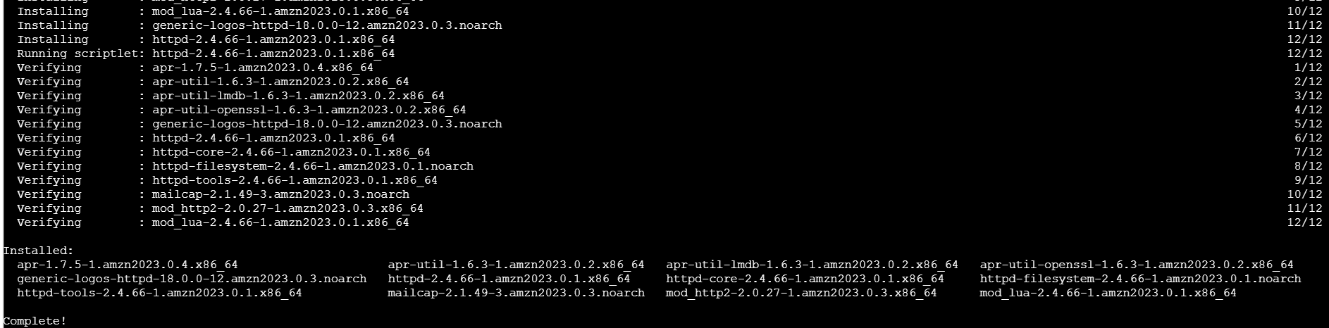

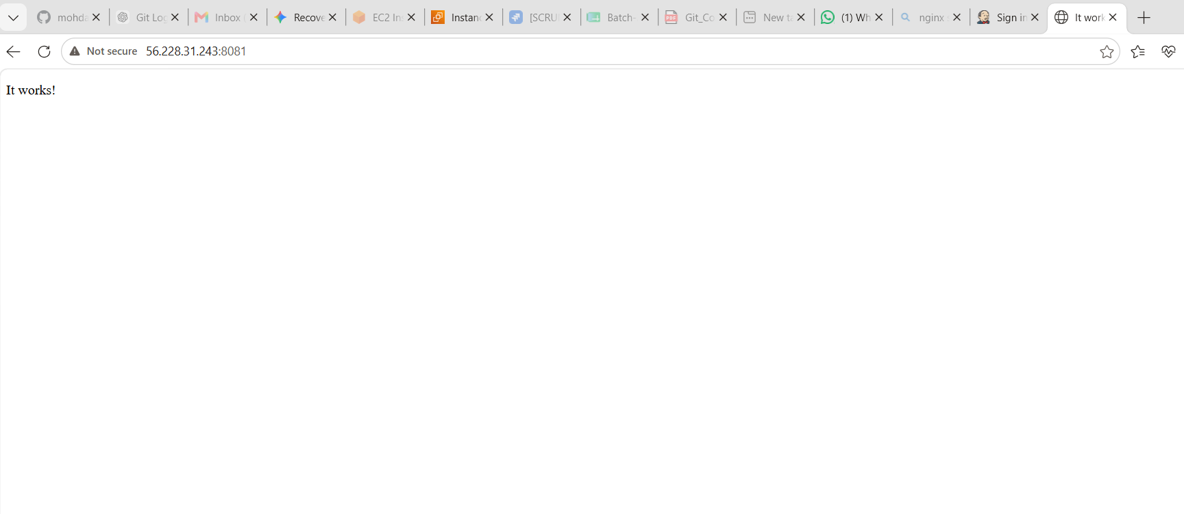

What We Learnt
- The Sockets Rule: In networking, an IP address combined with a port number forms a unique network socket connection string. Only one application engine can bind to a specific socket at a time. Managing multi-app servers requires careful port routing.
Naming Conventions: In Ubuntu/Debian Linux, Apache is called apache2. In Amazon Linux/CentOS/RedHat, it is always called httpd (which stands for HTTP Daemon). Same software, just a different package name across families

5.Install and Start Nginx
Run these commands in your terminal as the root user:
- Step Executed: Deployed Nginx to act as the primary HTTP web entry point on standard port 80.
- Implementation Commands:
Bash
# 1. Fetch and install the Nginx software package
dnf install nginx -y

# 2. Activate the network listening process and save boot structures
systemctl start nginx
systemctl enable nginx
- Outcome Verification: Running systemctl status nginx confirms active performance on Port 80.
Final Verification Checklist
To confirm that all independent web spaces are operating correctly without conflicting with one another, run the following network audit script:
Bash
netstat -tuln | grep -E '80|8080|8081'

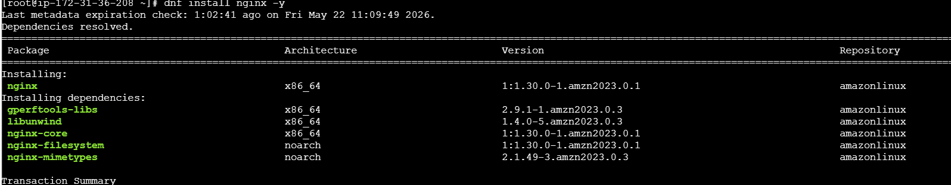

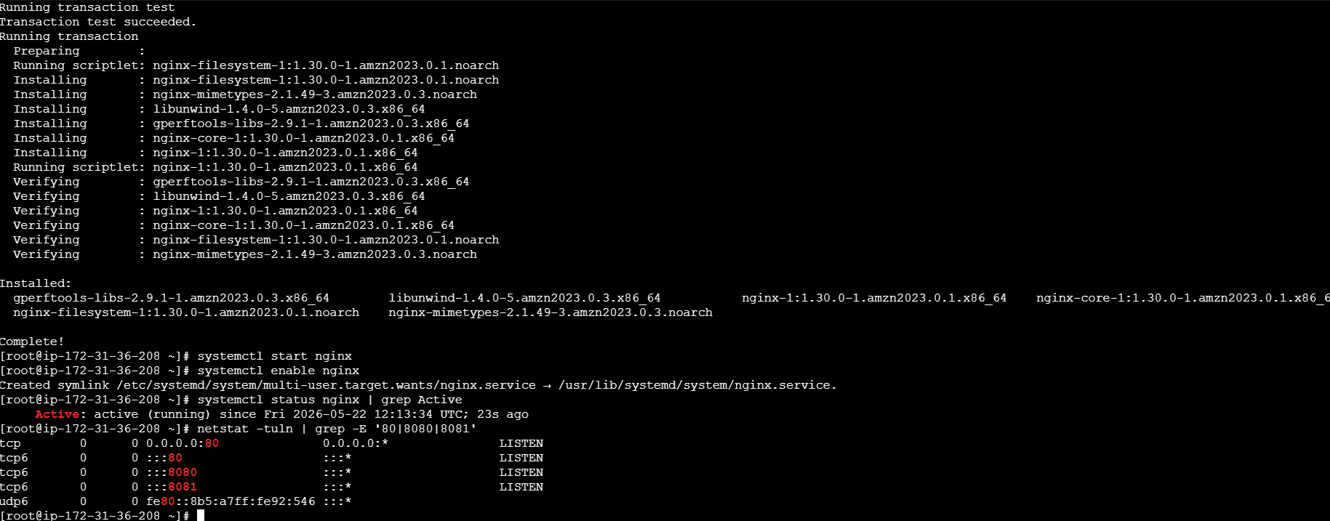

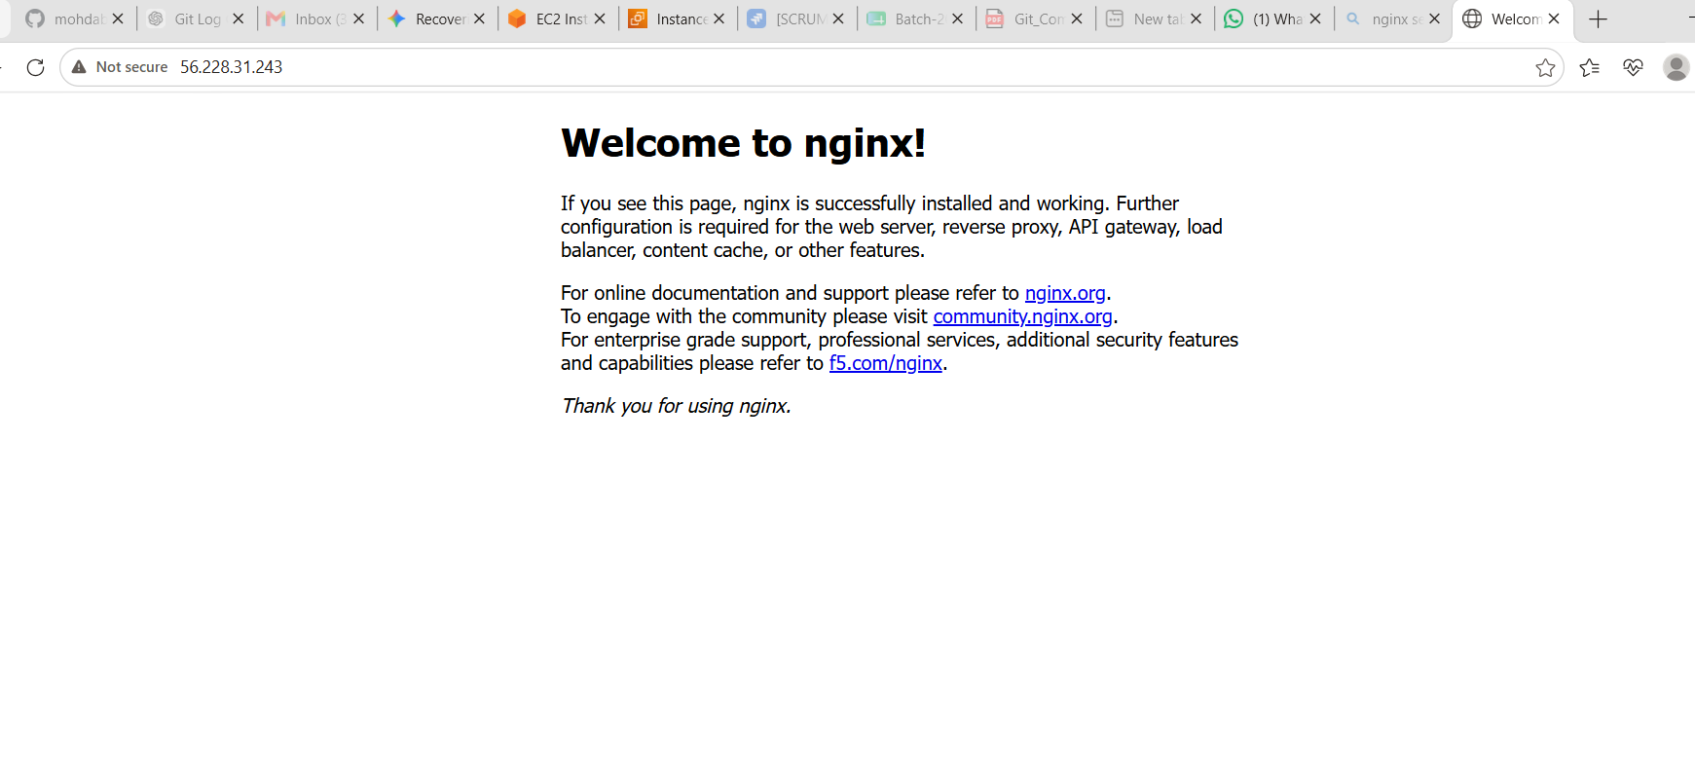
What We Learnt
- Default vs. Custom Ports: Most web servers default to port 80 because that is the global internet standard for unencrypted web traffic (http://). When building a multi-service development stack on a single server, you must designate one tool to own that primary port (Nginx in this case) and shift the rest to alternate ports.
- Non-Conflicting Coexistence: Because we modified Apache to use 8081 in the last step, Nginx is able to bind to port 80 instantly without causing a port allocation crash.

6. Install Apache Tomcat.

Steps:
Apache Tomcat Application Server Deployment
--To finish the foundational application delivery infrastructure stack, Apache Tomcat 10 was deployed to process dynamic Java web software containers (servlets and JSPs).

--Port Optimization Logic: To avoid an immediate network socket collision with the active Jenkins server (which owns port 8080), Tomcat's internal XML connector properties were stream-edited to point exclusively to port 8082.

--Implementation Commands:
cd /usr/local
--wget https://archive.apache.org/dist/tomcat/tomcat-10/v10.1.24/bin/apache- tomcat-10.1.24.tar.gz
-- tar -xf apache-tomcat-10.1.24.tar.gz && mv apache-tomcat-10.1.24 tomcat
-- sed -i 's/port="8080"/port="8082"/g' /usr/local/tomcat/conf/server.xml
--/usr/local/tomcat/bin/startup.sh

--Outcome Verification: Network socket auditing confirms the background JVM runtime is running stable and cleanly listening for inbound browser connections on port 8082. The live server dashboard is now reachable via browser at http://<your-ec2-public-ip>:8082.

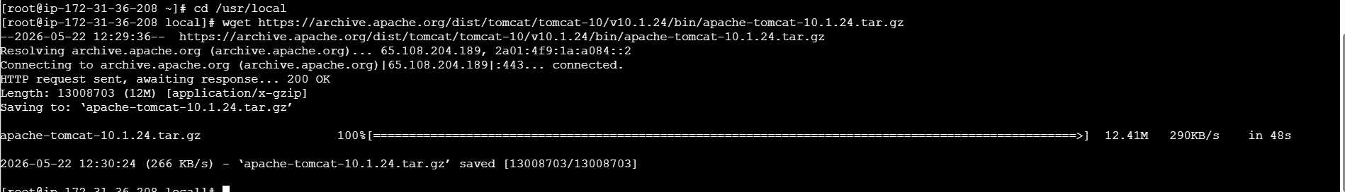
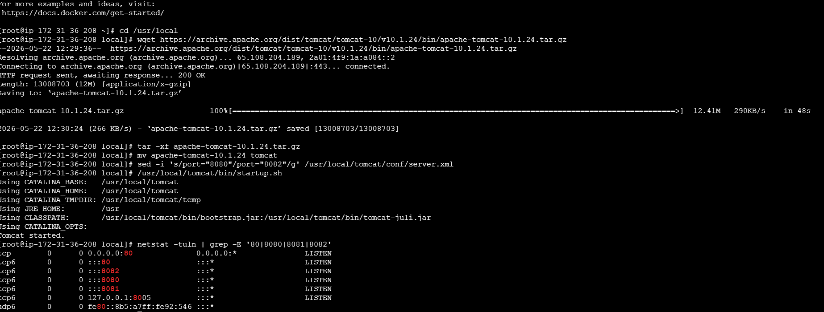

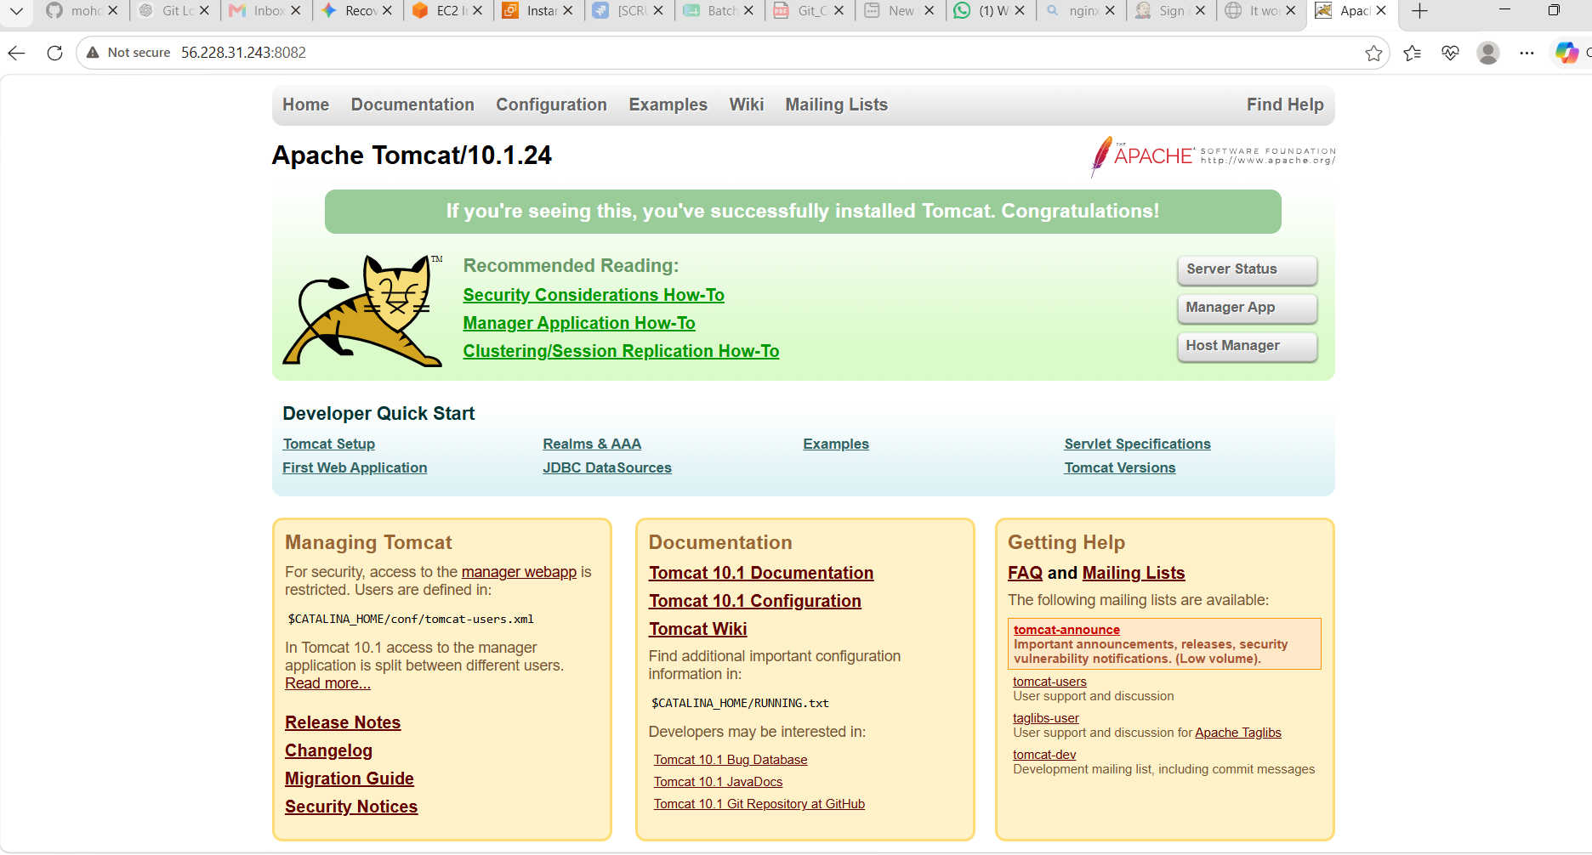

What We Learnt (Key Engineering Takeaways)
- Web Servers vs. Application Servers: * Apache HTTPD & Nginx are traditional Web Servers. They excel at handling static content (like HTML files, CSS sheets, and images) with extreme speed and minimal RAM overhead.
  - Apache Tomcat is an Application Server (specifically a Java Servlet Container). It contains a heavy execution engine built specifically to process dynamic server-side Java code, such as Java Server Pages (JSPs) and Java servlets compiled into .war (Web Archive) packages.
- Port Planning in Multi-Tenant Nodes: When configuring a single EC2 instance to play host to multiple heavy DevOps platforms, you must architect a strict port blueprint. By dividing the server's network stack deliberately into individual channels, you allow massive platforms to live alongside one another seamlessly:

[ THE CHALLENGE MATRIX]

1. FIREWALL GAPS ---> Blocked browser traffic (Port 8080/8081/8082)
2. RESOURCE CRUNCH ---> 1 GB RAM instance at risk of OOM crashing
3. OS DEPRECATION ---> Legacy installation commands failed on AL2023
4. RUNTIME MISMATCH ---> Version mismatch (Jenkins required Java 21, not
5. PORT COLLISIONS ---> Multiple services competing for Ports 80 & 8080

- Everything setup and running on the same EC2.
You we can change the port numbers as required.

- [Port 80] ----> Nginx (Public Gateway Proxy)
- [Port 8080] ----> Jenkins (Automation/CI-CD Engine)
- [Port 8081] ----> Apache HTTPD (Static Asset Server)
- [Port 8082] ----> Apache Tomcat (Java Application Runtime)

